**SIMULINK MODEL OF ANTI-LOCK BRAKING SYSTEM**



Prepared for



The Society of Automotive Engineers

Collegiate Club Number - SAEICCBIS022  
National Institute of Technology Karnataka

Prepared by

Kurma Eshwar Sai Srinivas – 181ME141 (Project Mentor)

Patrike Vedika Rajkumar – 191ME256

Diksha Negi – 191ME129

May 15, 2021

ABSTRACT

An Anti-Lock Braking System (ABS) is an active safety feature in aircrafts and land vehicles used to prevent wheel lock up and skidding during braking. This allows the driver to maintain more control over the vehicle whenever the wheels get locked. ABS requires improvement in the areas of stability, steerability and stopping distance. In this project we present a mathematical model of quarter vehicle including aerodynamic parameters and the implementation of ABS modelling using MATLAB Simulink. The non-linearity associated with the road friction coefficient and various input arguments like mass, velocity, aerodynamics parameters make it necessary for a robust tuning algorithm. The framework here is limited to demonstrating uniquely for straight-line slowing down with PID Tuning algorithm and slip control system. The performance of the Open loop system and the PID Controller have been compared.

Table of Contents

SECTION – I INTRODUCTION 2

Timeline 3

Tools and Technologies 3

Brief Introduction 3

Literature Review 4

SECTION – II CONCEPT DEVELOPMENT AND EVALUATION 4

Introduction 4

Methodology 6

Results and Discussion 15

Conclusion 18

Future Scope 19

References: 19

# SECTION – I INTRODUCTION

## Timeline

|  |  |  |
| --- | --- | --- |
| Month | Week | Task Accomplished |
| Dec-20 | One | Introductory Meet – Project Start |
| Dec-20 | Two | Completed MATLAB Fundamentals Course from MathWorks |
| Dec-20 | Three | Learnt Simulink from SAE KEP |
| Jan-21 | Three | Started Learning Basic Vehicle Dynamics – (Brake Bias) |
| Feb-21 | One | Learnt Load Transfer Calculations for a Half Car Model – (NPTEL) |
| Feb-21 | Four | Project Review – 01 |
| Mar-21 | Two | Literature Review for ABS Simulink Model |
| Apr-21 | Four | Started Making Simulink Model of Braking System (Open Loop) |
| May-21 | One | Added PID Controller to the Open Loop Model and Tuned |
| May-21 | Two | Added Drag and Downforce to the Simulink Model |
| May-21 | Two | Project Review – 02 (Final Review) |
| May-21 | Three | Documentation and Submission of Final Report |

## Tools and Technologies

|  |  |  |
| --- | --- | --- |
| S. No | Tool / Technologies used | Remark |
| 1 | MATLAB  Modules Used: Simulink, Control Engineering Toolbox | Coding and Optimization |
| 2 | Microsoft Excel | Plotting graphs |

## Brief Introduction

An Anti-Lock Braking System is an active safety feature in aircrafts and land vehicles used to prevent wheel lock up and skidding during braking. This allows the driver to maintain more control over the vehicle. It can decrease the breaking distance on dry and regular roads. ABS requires improvement in the areas of stability, steerability and stopping distance.

In this project, a model of the quarter vehicle is developed and used to study the braking performance of a straight-line braking test vehicle on flat dry asphalt road in MATLAB-Simulink software environment. The vehicle model includes the aerodynamic model and a model of antilock braking system. As this is a simulation model, there is no chance of using a real-time sensor for getting the wheel speed and vehicle speed. We have used newton’s kinematic equations to get the values of the same. We have avoided the hydraulic modulator and we are directly adjusting the brake torque from the feedback loop. Also, The framework here is demonstrated uniquely for straight-line slowing down. If there should be an occurrence of cornering, the side slip ratio would be controlled so that wheels don't lock and subsequently guaranteeing steerability.

## Literature Review

Sharkawy has studied the changes in coefficient of friction at various road conditions. We have extracted friction formula from this literature and have plotted the same at various velocities. He has also tuned the ABS with Genetic algorithm and fuzzy. However, we have made an attempt to tune the ABS PID model with Genetic algorithm.

Bhivate has made the Simulink model of Antilock brake system without the aerodynamic compenents. He has used state space equations of motion to model the Simulink model. In this project we did the Simulink model with direct calculation and the results were reasonable matching. Direct calculation is a much simpler method.

Rangelov has modelled antilock braking system for a quarter car model on a flat as well as uneven road. He has made the ABS based on various methodologies like slip control, acceleration control, tire moment control braking. He has also included suspension model to the quarter car vehicle.

Harifi made primary controller design has been improved using integral switching surface to reduce chattering effects. He also he compared the performance of the designed controller with three of the prevalent papers results to determine the performance of sliding mode control integrated with integral switching surface.

# SECTION – II CONCEPT DEVELOPMENT AND EVALUATION

Introduction

The ABS consists of wheel speed sensor, hydraulic modulator and an Electronic Control Unit (ECU). It has a feedback system which finds out the error between the actual and desired slip ratio and adjusts the Brake Pressure accordingly to get the optimum slip ratio and maximum traction. They System Shuts down if the vehicle speed is under the pre-set threshold.

Before getting into more details, it is important to understand the motivation and need to prevent wheel skidding. wheel locking is when the tyre stops rotating under braking and slides along the top of the surface. It is bad firstly because it is less efficient (coefficient of kinetic friction is lower than coefficient of static friction) (explained in fig under $μ$ Subsystem of Simulink) and so will take longer to slow you down but more importantly also because it can wear a flat spot on the tyre if it locks for a long time. Flat spotted tyres tend to lock more easily in the future at the point of the flat spot and also cause vibrations which can damage the car.

During breaking, you are using brake pad friction on the wheels to slow you down. When you break hard, sometimes, the brake pads stop the wheel from spinning. in other words, when the brake pads are so tightly pressed against the drum/disc, the wheel locks up. Now although the wheel is not moving, because of your momentum, you will still keep moving forward for a short distance, this is skidding, where the tyres/tires don’t roll over the tarmac but are dragged. You have very little control over the vehicle when this happens.

In Ancient time, a balance bar was used to adjust the brake bias instead of an ABS system. The function of a balance bar is to allow the adjustment of brake line pressure distribution between two master cylinders. The torque on one side of the bar must balance the torque on the other side. Balancing bars take the force from one side and give it to the other. The Brake bias/Brake balance, front to rear, is critical to the stability of a racing car during the braking and during turn-in phase; too much rear brakes will tend to cause the car to spin; too much front and car will not turn in. Brake biasing is only seen in racing cars.

Brake biasing is the condition where we give different brake forces to rear and front wheels. Generally, we give more braking force to the front than to the rear as the centre of gravity tends to move forward when we apply brakes. For the stability of the vehicle both the wheels should skid at the same time.

When the Front wheels locks, there is loss of steerability i.e., it caused understeer due to absence of lateral friction. If the front wheels get locked, the driver loses the steering control. However, this can be detected more readily by an experienced driver and the driver can regain control by releasing the brakes. But, when the rear wheels locks, it is more critical as directional stability is lost and there are chances that the car spins out. In this scenario the vehicle over responds to the steering and the rear part of the vehicle rotates about its axis if any lateral perturbation is applied to the vehicle. Although the ABS is unable to adjust the locking up of wheel, it is essential for ABS to get the right sequence of locking up.

## Methodology

Assuming that the mass is equally distributed on all the four wheels of the vehicle. We consider the mass of a quarter car model at 0.25*m. The Kinematic equations of motion of the quarter car model are as follows:

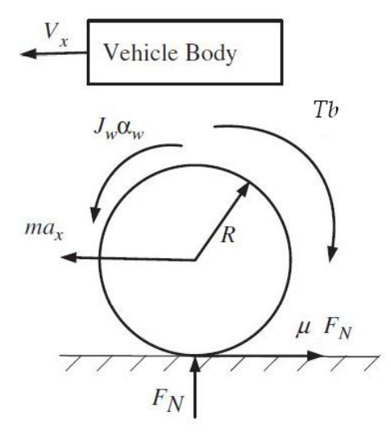Equation for braking force balance in longitudinal direction (vehicle)

Figure 1 Quarter Car Vehicle Model

The Down Force on the vehicle is

$$F_{down}=\frac{1}{2}C_{l}WH{V_{x}}^{2}$$

The Normal Force of the Vehicle

$$F_{N}=0.25(F_{down}+mg)$$

The Drag Force of the Vehicle

$$F_{drag}=0.25*\frac{1}{2}ρC_{d}A_{f}{V_{x}}^{2}$$

For a Quarter Car Model: $F_{drag}^{'}=0.25 F_{drag}$

The Equation of Motion from Newton’s Second Law

$$ma_{x}= -μF_{N}-F_{drag}$$

$$⇒a_{x}= \frac{-μF_{N}-F_{drag}}{m}$$

$$⇒a_{x}=\frac{- μ\left(mg+\frac{1}{2}ρC_{d}A_{f}{V_{x}}^{2}\right)}{m}$$

Balancing the Torque at the Wheel Centre

$$J_{w}α_{w}= μRF_{N}-T_{b}$$

$$ω=∫α_{w}ⅆt⇒ ω=∫\frac{ μRF_{N}-T_{b}}{J_{w}}ⅆt$$

(Assuming the Downforce and Drag forces are passing through the wheel centre, we have not included them in the torque equations)

Now, Wheel Slip Ratio can be defined as $λ=1-\frac{Rω}{V_{x}}$

In Case of pure rolling, we have $V_{x}=Rω$, and the value of $λ=0$. On Contrast, in case of skidding we have $Rω=0$ which make the value of $λ=1$.

In this paper, the tire friction model introduced by Burckhardt (1993) and adopted in Harifi et al. (2008) has been used. It provides the tire-road coefficient of friction $μ$ as a function of the wheel slip $λ$ and the vehicle velocity Vx. Researches show that the road coefficient of adhesion is a nonlinear function of wheel slip ($λ$) and the vehicle velocity (Vx) in a specified road condition. The road friction coefficient function is as follows:

$$μ\left(λ,V_{x}\right)=[c_{1}\left(1-e^{-c_{2}λ}\right)-c_{3}λ]e^{-c_{4}V_{x}}$$

Where, c1 is the maximum value of friction curve

c2 is the friction curve shapes/slope

c3 is the friction curve difference between the maximum value and the value at = 1

c4 is the wetness characteristic value, which varies from 0.02-0.04 s/m

From the above graph it is observed that the maximum slip is attained at a slip ratio of 0.2. However, in case of Snowy and icy road there is no significant change in the road friction coefficient at different values of slip. The Plots Below are plots of different types of road at varying vehicle speeds.

Figure 2 Road friction coefficient v/s Wheel Slip ratio at vehicle speed 30 m/s

|  |  |  |  |
| --- | --- | --- | --- |
| **Surface** | **C1** | **C2** | **C3** |
| Dry asphalt | 1.2801 | 23.99 | 0.52 |
| Wet asphalt | 0.857 | 33.822 | 0.347 |
| Dry Concrete | 1.1973 | 25.168 | 0.5373 |
| Snow | 0.1946 | 94.129 | 0.0646 |
| Ice | 0.05 | 306.39 | 0 |
| Current Study | 1.28 | 12 | 0.28 |

Table 1 Road friction coefficient parameters set for different road surfaces.

The Value of c4 varies from 0.02 s/m to 0.04 s/m depending on the wetness of the road.

Figure 3 Road friction coefficient of road of current study at different velocities

Figure 4 Road friction coefficient of Snowy road at different velocities

Figure 5 Road friction coefficient of Wet Asphalt road at different velocities

Figure 6 Road friction coefficient of Dry Concrete road at different velocities

Figure 7 Road friction coefficient of Dry Asphalt road at different velocities

Figure 8 Road friction coefficient of Icy road at different velocities

There is no significant change in the wheel slip point at which friction attains its peak value for almost all kinds of roads. So, slip ratio of 0.2 can be made as a universal optimum slip value.

A feedback control system is a closed loop control system in which a sensor monitors the output (slip ratio) and feeds data to the controller which adjusts the control (brake Torque) as necessary to maintain the desired system output (match the wheel slip ratio to the reference value of slip ratio). The PID Controller flow diagram is as shown below.

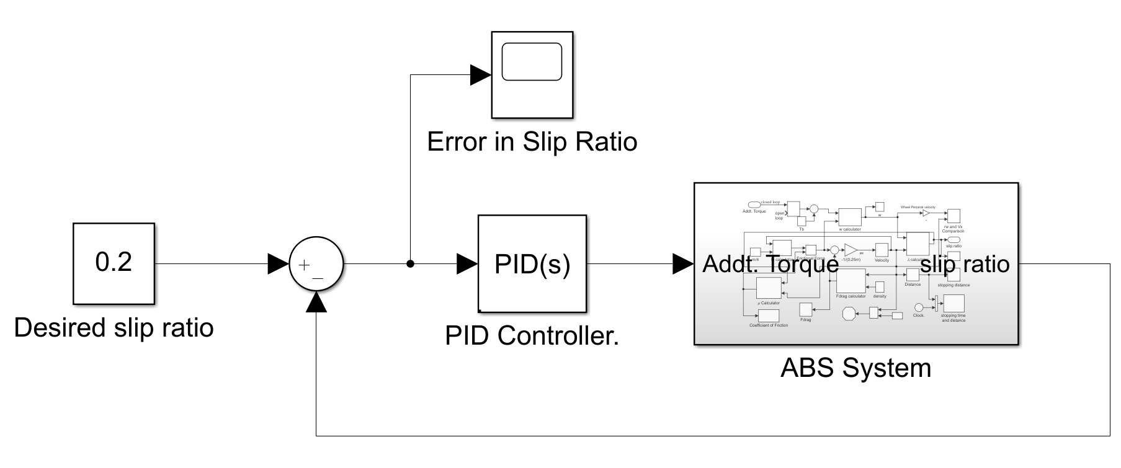

Figure 9 The ABS Control System

The PID Tuner take the Error in slip ratio and accordingly sends the additional torques (either positive or negative) and gets the value of slip ratio again. This process continuous till the Vehicle velocity is less than the threshold i.e., it is 0.5 m/s in our project. In our project we have tuned the PID Controller manually and we have achieved fastest response at Kp = 250000; Ki =100000; Kd =100.

The Flow Diagram the Complete Vehicle Dynamics Block of the ABS Model is as follows:

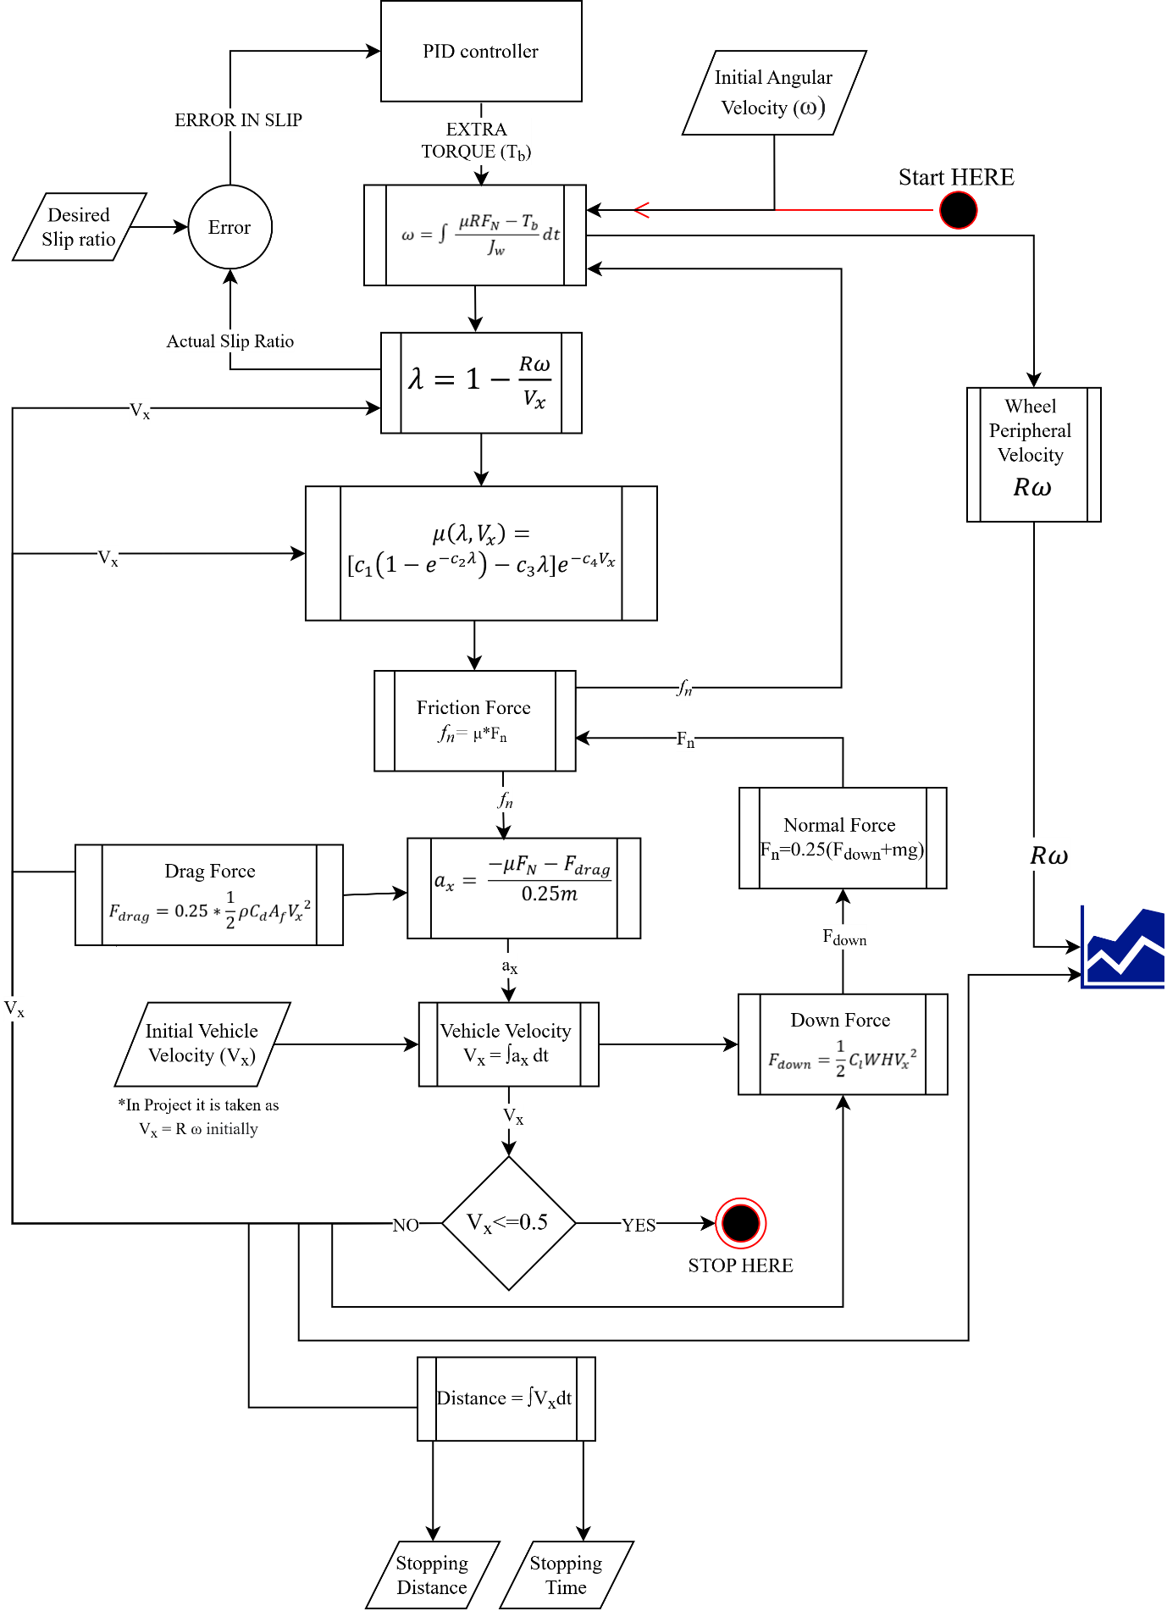

Figure 10 Complete Flow Diagram of the Simulink Model

The Simulink model of the above Figure is as shown below. To avoid confusion various subsystems have been made.

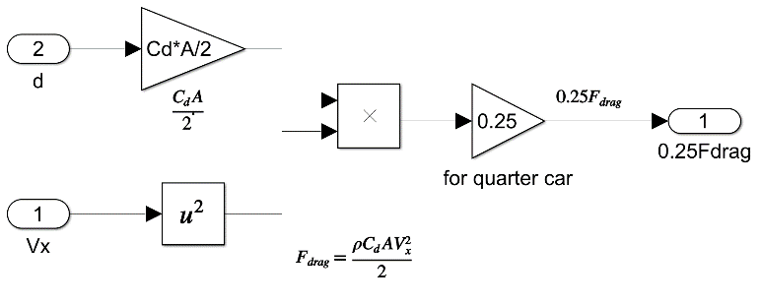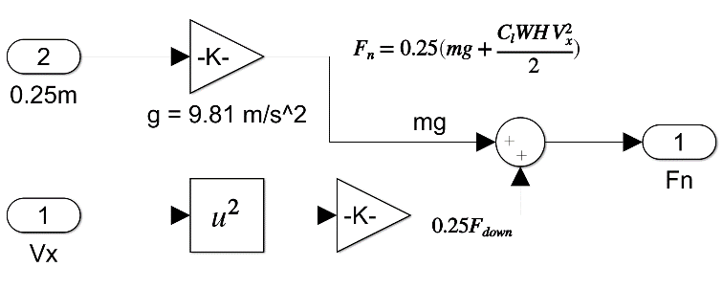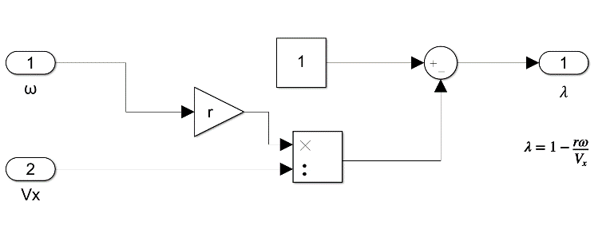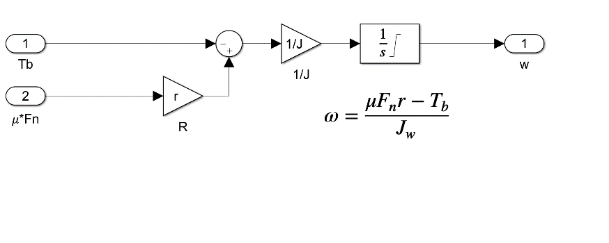 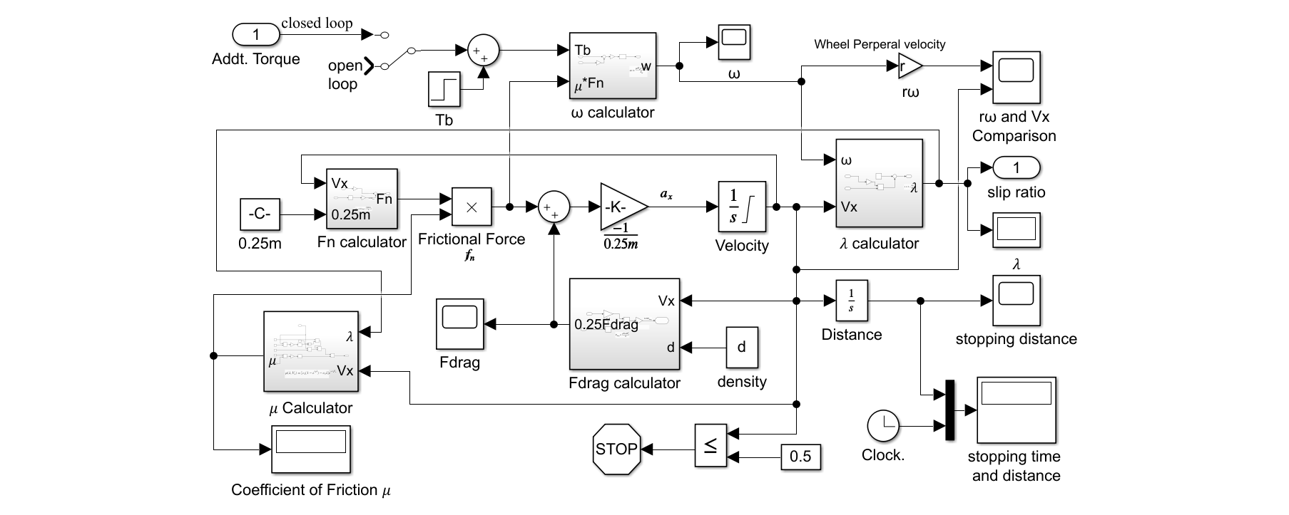

Figure 11 Drag Force Calculator

Figure 12 Normal Force (+Downforce) Calculator

Figure 13 ω calculator Sub-System

Figure 14 𝜆 Calculator Sub-System

Figure 15 Simulink Model of ABS Sub-System

The Flow diagram (Figure) is self-explanatory. Parameters like Downforce and Drag force are assumed to be acted on the centre of the wheel (But Practically, they are not in this way) Hence, no torque develops from them in this model.

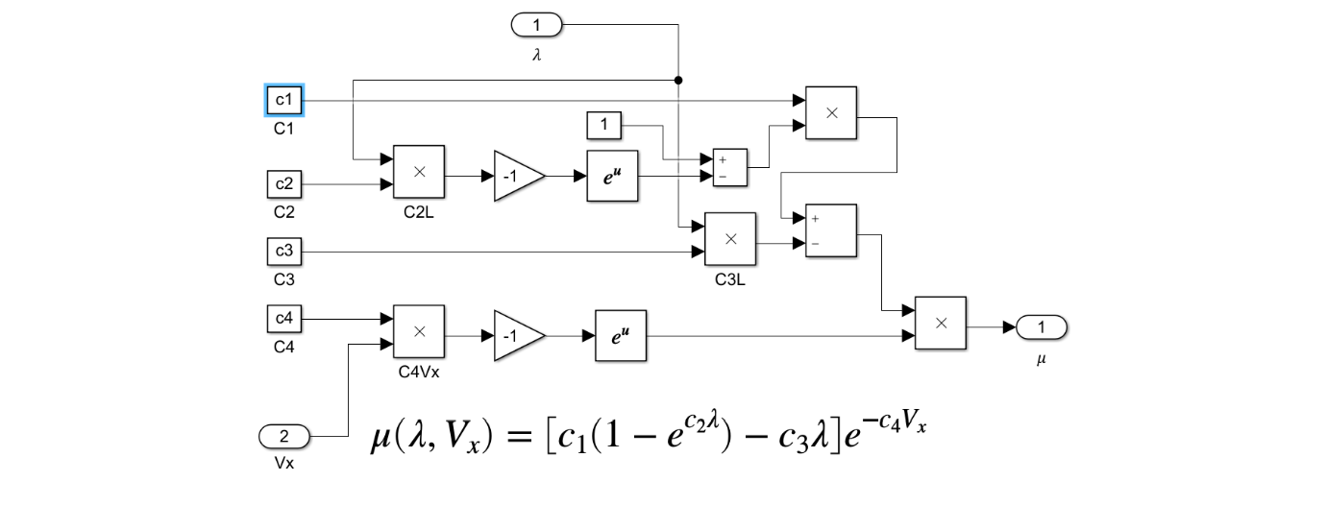Combining all the above block we get the final Simulink Model. A Simpler Version of the Simulink Model has been shown in the Flow Diagram.

Figure 16 Road Friction Coefficient (Mu) Calculator

## Results and Discussion

The Simulation has been run with P, PI, PD, PID Controller and compared with Open loop System for straight line braking system. The input parameters used for the simulation are

r = 0.33 m; m = 342 kg; Jw = 1.13 kgm2; g = 9.81 m/s2; Tb = 1200 N-m;   
Vx = 100 km/hr = 27.78 m/s; ωx = Vx/r = 84.14 rad/sec; λd = 0.2; Kp = 250000;

Ki = 100000; Kd = 100

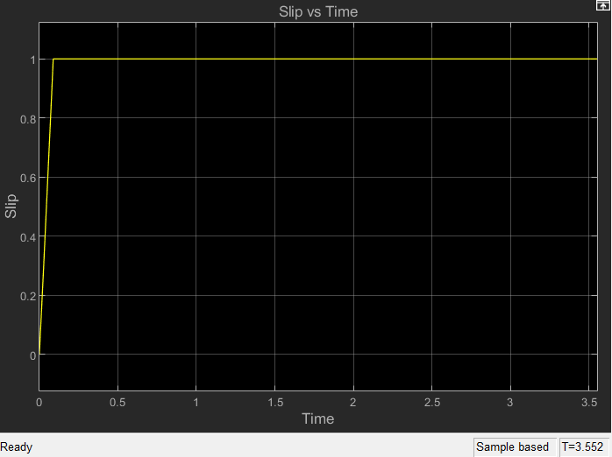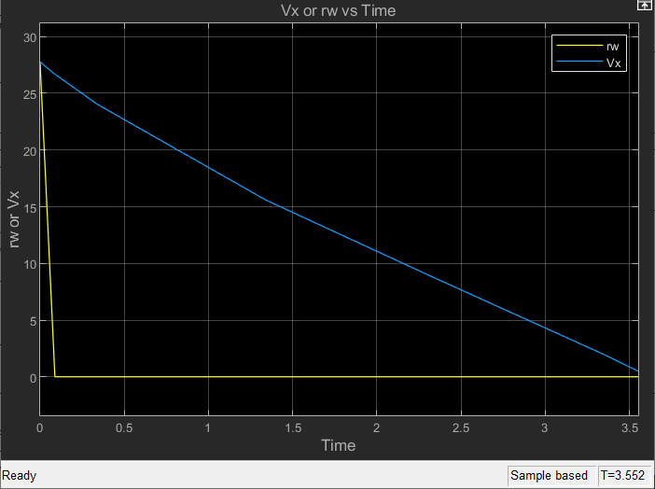The Fig is the Graph between Vx and Rw in an open loop system. We can clearly observer that in fig a we w = 0 in the initial stage itself. This implies the wheel keeps skidding until Vx=0. When the wheel skids the Value of Lambda = 1 which is evident in Fig

In case of P Controller we can see that initially, the wheel pheripheral velocity is about to fall to zero, i.e., it was about to skid. But, due to the proportional gain in the error. The wheel are made to rotate until the vehicle velocity comes reaches the threshold. In the slip ratio v/s time graph, we can see that there is a slight steady state error in the graph which can be acceptable 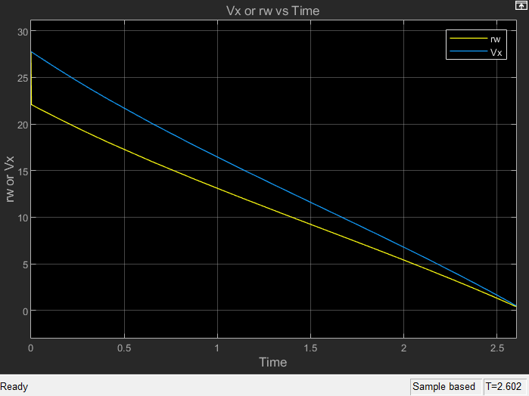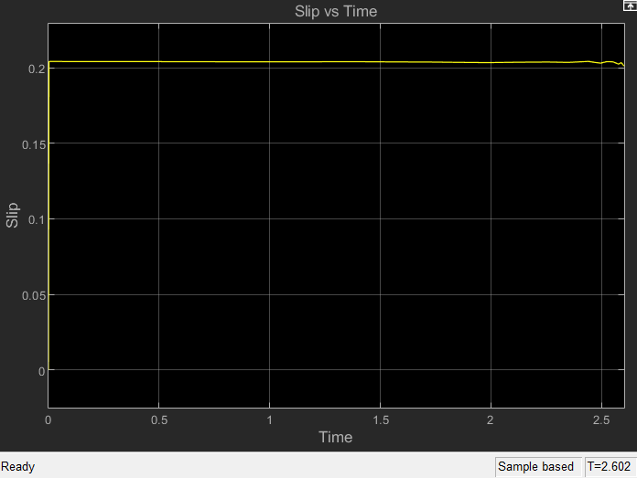and it can also be corrected by using Integrator/Derivative gains.

Almost Similar Results were obtained in PI, PD and PID Controllers also. There is a minute change in stopping time, i.e., in the order of 0.001 seconds.

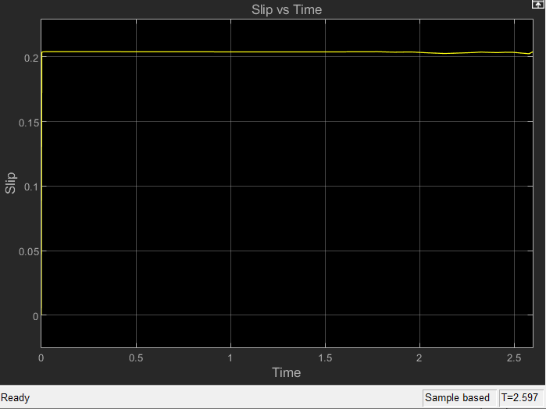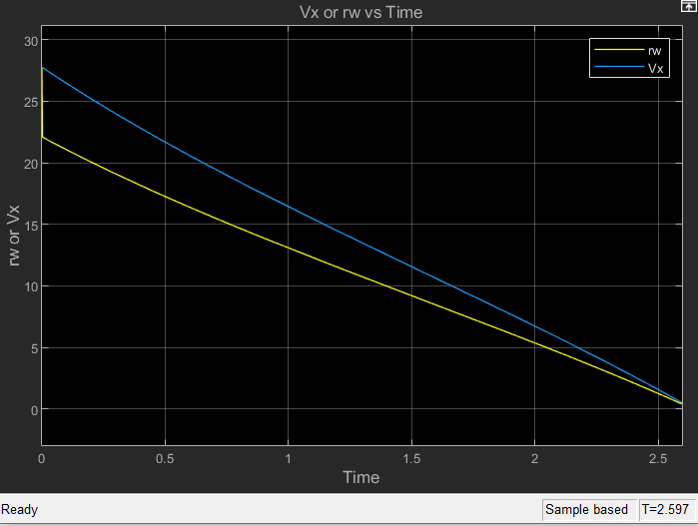The PD Controller results shown below. The PD Controller tried to Correct the derivative error which was seen in P controller, but was not very successful

The PI Controller results are as follows. The Steady State error has been slightly corrected in PI Controller.

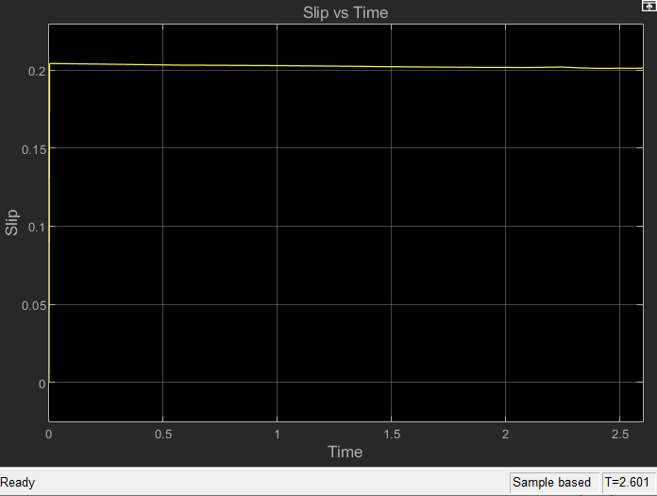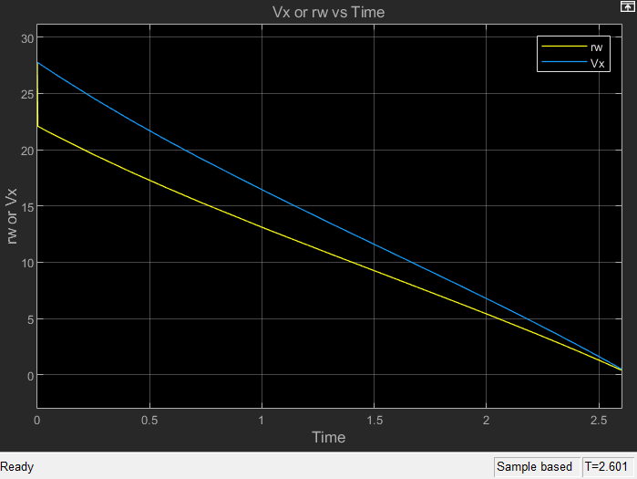

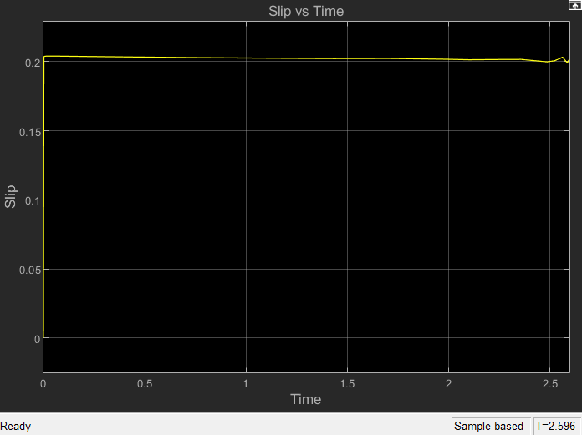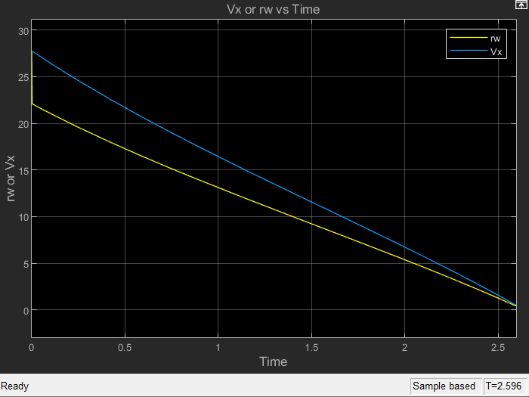The PID Controller result is shown below.

Although The steady state error has been corrected here. It is good to only use a P controller in this system as there is no significant change in the system. P controller can be used to be efficient and economic. The Results of all types of Controllers is compared with the open loop system as shown in the below table.

Table 2 Comparison of ABS Outputs with Different Controllers

|  |  |  |  |
| --- | --- | --- | --- |
| Controller | Stopping Time | Stopping Distance | Road Friction Coefficient |
| Open Loop | 3.552 | 46.18 | 0.7488 |
| P Controller | 2.602 (-27%) | 35.66 (-23%) | 1.148 (+42%) |
| PI Controller | 2.601 (-27%) | 35.65 (-23%) | 1.148 (+42%) |
| PD Controller | 2.597 (-27%) | 35.61 (-23%) | 1.147 (+42%) |
| PID Controller | 2.596 (-27%) | 35.6 (-23%) | 1.148 (+42%) |

From the above table we can notice that there is a 27% reduction in stopping time, 23% reduction in stopping distance and 42% increment in the Road friction coefficient with P/PI/PD/PID Controllers. It is best to use just a P controller to save costs and be efficient.

## Conclusion

In this project an attempt is made to understand the application of various type of linear controller used for antilock braking systems. The system was modelled with a quarter vehicle dynamics and motions equations of motion was formulated. The slip ratio is used control as a criterion for this control work. However, a literature review was done on various types of control systems for ABS. An attempt was made to auto-tune PID using Genetic algorithm from global optimization toolbox in Simulink. Observations in response for slip ratio have been made using trial and error tune P, PI, PD, PID controller and comparison is also made with open loop system.

## Future Scope

The current simulations are done for a quarter vehicle model. Future simulations can be done on a half vehicle (bicycle) model or even a full vehicle model. Further forces like Roll and Dive forces would be added in a model which consists of more than one wheel. Suspension System can be added to the Simulink model and further tuning can be done. Also, we can integrate powertrain to this model to make it more robust. If specific to Control system is the need, then we could also go for different auto tuning systems like Fuzzy Logic control, Genetic Algorithm or any other available in the literature. There a vast scope on this simple project which can be taken up by the upcoming generations of SAE-NITK.

References:

* [NPTEL lectures on ABS](https://nptel.ac.in/courses/107/106/107106088/)
* [Understanding ABS](https://www.youtube.com/watch?v=98DXe3uKwfc)
* [Investigation of Anti-Lock Braking System performance Using different Control System](https://www.researchgate.net/publication/340539375_Investigation_of_Anti-Lock_Braking_System_Performance_Using_Different_Control_Systems)
* [NPTEL lectures on Vehicle Dynamics](https://www.youtube.com/watch?v=LZ82iANWBL0&list=PLbMVogVj5nJTW50jj9_gvJmdwFWHaqR5J)
* [S. B. Choi, ‘Antilock Brake System with a Continuous Wheel Slip Control to Maximize](http://acl.kaist.ac.kr/Thesis/2008_CST.pdf)

[the Braking Performance and the Ride Quality’, IEEE Transactions on Control Systems Technology, vol. 16, no. 5, September 2008](http://acl.kaist.ac.kr/Thesis/2008_CST.pdf)

* Abdel Badie Sharkawy (2010). Genetic fuzzy self-tuning PID controllers for antilock braking systems. , 23(7), 1041–1052. doi:10.1016/j.engappai.2010.06.011
* [Bhivate, Parth. “Modelling & development of antilock braking system.” (2011).](http://ethesis.nitrkl.ac.in/2644/1/Modelling_and_Development_of_Antilock_Braking_System.pdf)
* [Rangelov K. SIMULINK model of a quarter-vehicle with an Anti-lock Braking System. Eindhoven: Technische Universiteit Eindhoven. Stan Ackermans Instituut, 2004.](https://research.tue.nl/en/publications/simulink-model-of-a-quarter-vehicle-with-an-anti-lock-braking-sys)
* A. Harifi, A. Aghagolzadeh, G. Alizadeh and M. Sadeghi, "Designing a Sliding Mode Controller for Antilock Brake System," EUROCON 2005 - The International Conference on "Computer as a Tool", 2005, pp. 258-261, doi: 10.1109/EURCON.2005.1629910.